
YJK Technologies
ESS-Attendance

Preface
Welcome to the YJK ESS Attendance User Guide.
This document provides detailed information about how employees can manage their attendance activities using the YJK Employee Self Service (ESS) system.

C H A P T E R

Introduction
This document explains the Attendance module features available in the YJK ESS system. It helps users understand Masters, Transactions, and Reports functionalities.
The YJK ESS Attendance Module is designed to help employees easily manage their daily attendance activities. It allows users to record in-time and out-time, view attendance history, apply for leave or permissions, and request corrections if needed.
This module ensures accurate tracking of employee attendance and provides a simple and user-friendly interface for managing attendance-related tasks efficiently.

Additional Points
- It helps maintain real-time attendance data for better monitoring.
- Reduces manual work and errors in attendance management.
- Provides quick access to attendance history and reports.
- Supports shift management and task tracking.
- Enables employees to update and track their daily tasks.
- Improves transparency between employees and management.
- Helps in generating accurate reports for decision-making.
- Ensures data consistency and reliability across the system

2. Masters
The Masters section is used to configure basic settings required for attendance and project tracking.
- Project
- Project Mapping
- Task
- Shift Master
- Setting Screen
3. Transactions
The Transactions section is used for daily operations and updates.
- Open Tickets
- Task Update
- Generate Shift
4. Reports
The Reports section provides insights and tracking of work and attendance data.
- Task Hours & Time Tracking
- Project Progress
- Project Chart Report
- Shift Summary Report

C H A P T E R

Master

Project Module

The Project screen is used to create and manage project details in the system. Users can enter important information such as project name, manager, estimated hours, start and end dates, priority level, and status.
It also provides options to save project details and search for existing projects using various filters like project name, manager, date range, and status. This helps in easy tracking and management of projects.
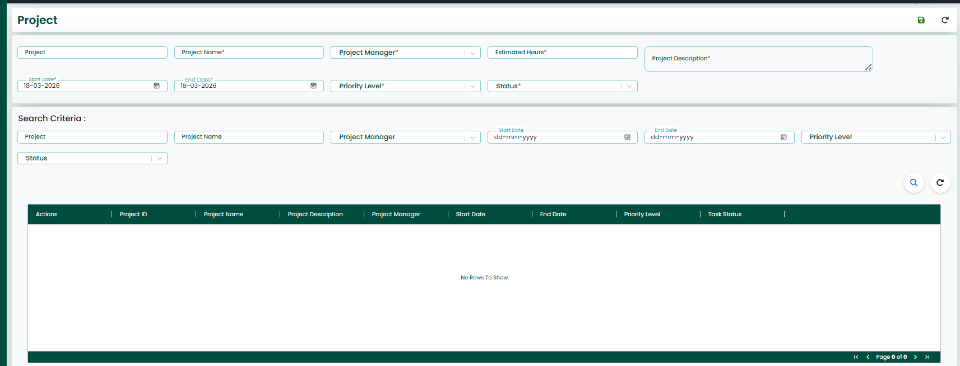
Project Entry Fields
The screen includes several input fields where users can enter the required project information such as project name, project manager, estimated hours, description, start date, end date, priority level, and status. After entering the details, the data can be saved and stored in the system.
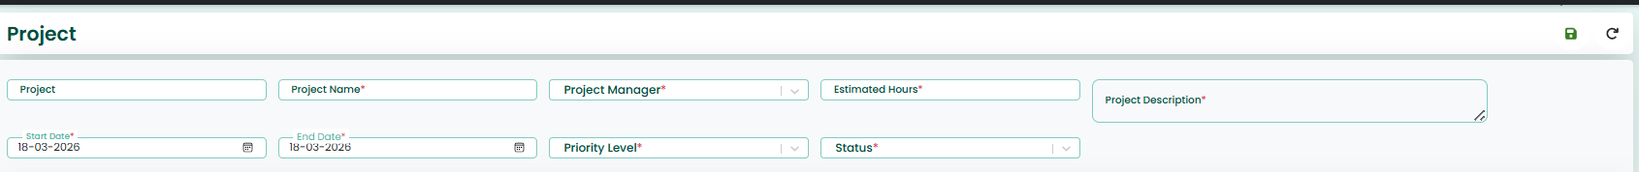
Action Buttons
- Save
Used to save the project details.
- Reload
Used to clear the entered data and refresh the screen.

Search Criteria
- The screen also provides search criteria fields, which allow users to filter and retrieve specific project records based on selected conditions such as project name, manager, date range, priority level, and status.
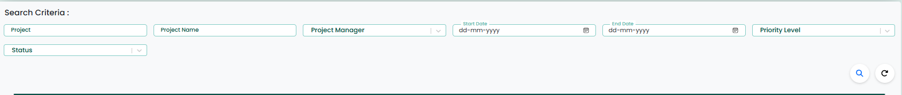
Search Actions
- Search
Retrieves project records based on selected criteria.
- Reload
Resets the search filters and reloads the data.
GRID
The retrieved records will be displayed in a grid format, making it easier for users to view and manage the available data. The grid also provides options to update or delete the existing records directly from the displayed list.
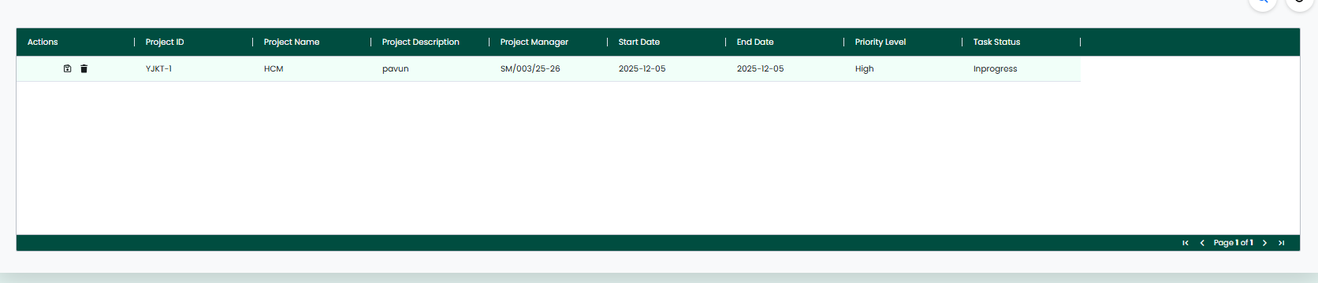

Actions Buttons
- Update
Used to update the project details.
- Delete
Used to Delete the project details.

Project Mapping
The Project Mapping Screen allows users to manage and maintain the mapping between projects and users within the system. This screen is used to assign users to specific projects for proper tracking and management.
The screen includes input fields where users can select the required details such as project and user. After entering the details, the information can be saved and stored in the system.
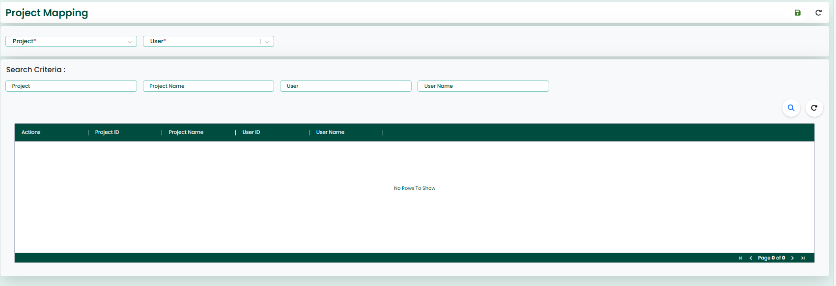
Action Buttons
- Save
Used to save the project details.
- Reload
Used to clear the entered data and refresh the screen.
Search Criteria
The screen also provides search criteria fields, which allow users to filter and retrieve specific project mapping records based on conditions such as project, project name, user, and user name.
Search Actions
- Search
Retrieves project records based on selected criteria.
- Reload
Resets the search filters and reloads the data.

GRID
The retrieved records will be displayed in a grid format, making it easier for users to view and manage the mapped data. The grid also provides options to update or delete the existing records directly from the displayed list.
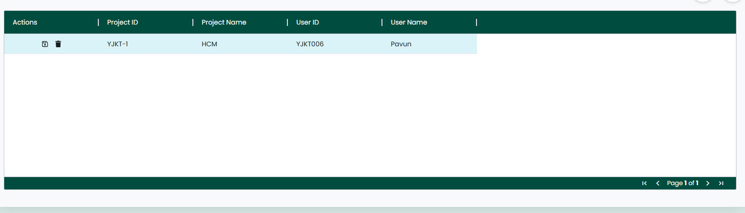
Actions Buttons
- Update
Used to update the project details.
- Delete
Used to Delete the project details.

Task

The Task Screen allows users to create, manage, and track tasks within a project. This screen is used to assign tasks to users and monitor task progress effectively.
The screen includes input fields where users can view project details such as project name, project manager, start date, end date, and project description. Users can also enter task-related information such as task master ID, user, task title, start date, end date, estimated hours, buffer hours, task status, priority level, and task description. Additionally, users can upload files related to the task. After entering the details, the data can be saved and stored in the system.
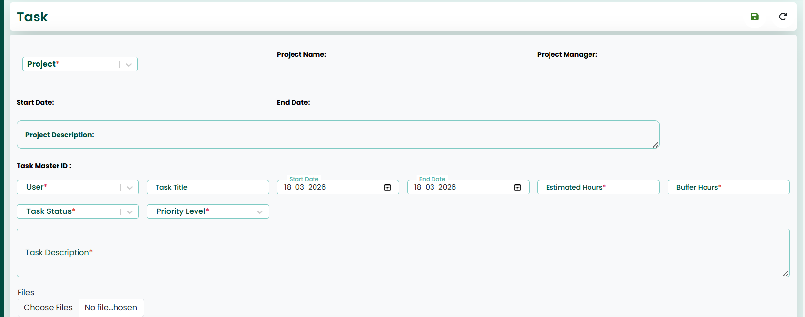
Action Buttons
- Save
Used to save the project details.
- Reload
Used to clear the entered data and refresh the screen.
Search Criteria :
The screen also provides search criteria fields, which allow users to filter and retrieve specific task records based on conditions such as project, task master ID, user, task title, task status, and date range.
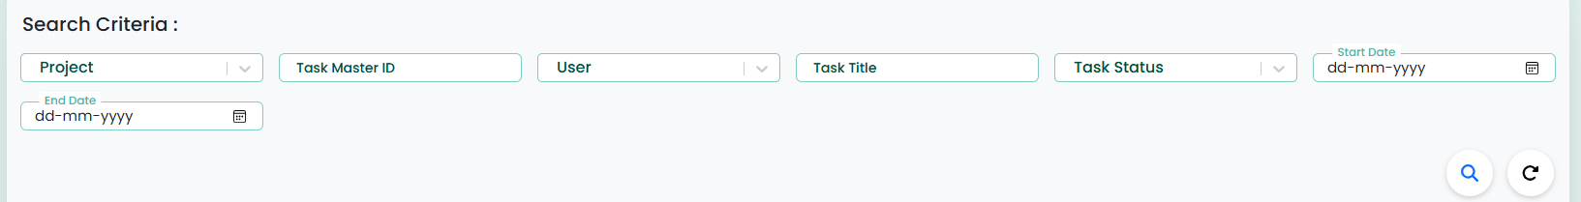
Search Actions
- Search
Retrieves project records based on selected criteria.
- Reload
Resets the search filters and reloads the data.

GRID
The retrieved records will be displayed in a grid format, making it easier for users to view and manage the task details. The grid also provides options to update or delete the existing records directly from the displayed list.
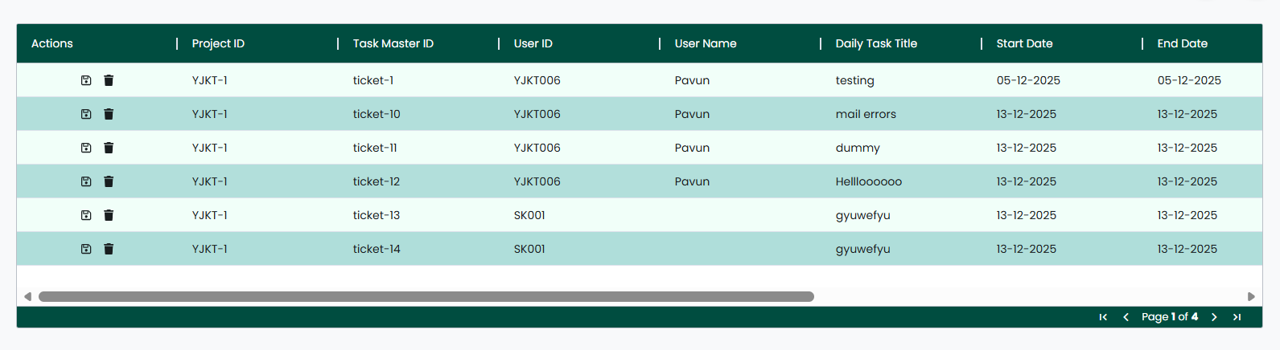
Actions Buttons
- Update
Used to update the project details.
- Delete
Used to Delete the project details.

Shift Management
Shift Management is the process of planning, organizing, and managing employee work shifts in an organization. It ensures that employees are assigned to the correct working hours based on business needs.
It involves defining shift timings (start time and end time), assigning shifts to employees, handling night shifts, managing weekly schedules, and tracking attendance based on shifts.
The screen also provides options to configure Shift Master, Shift Pattern Master, Shift Pattern Details, and Employee Shift Mapping, which help in organizing and assigning shifts effectively.

Shift Master
The Shift Master Screen allows users to create and manage employee shift details within the system. This screen is used to define different shift timings and configurations required for attendance management.
The screen includes input fields where users can enter shift-related information such as shift code, shift name, start time, end time, shift hours, night shift indicator, grace in minutes, grace out minutes, cross midnight option, and status. After entering the details, the data can be saved and stored in the system.
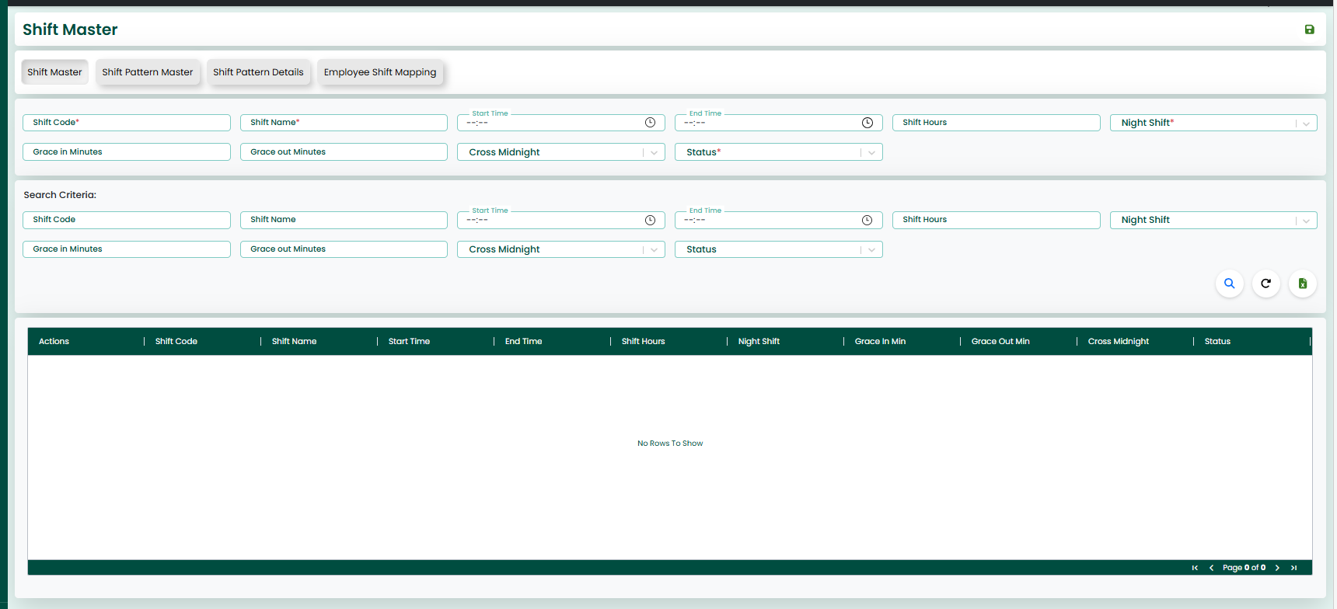
Action Buttons
- Save
Used to save the project details.
- Reload
Used to clear the entered data and refresh the screen.
Search Criteria :
The screen also provides search criteria fields, which allow users to filter and retrieve specific shift records based on conditions such as shift code, shift name, timing, shift hours, night shift, grace time, cross midnight, and status.
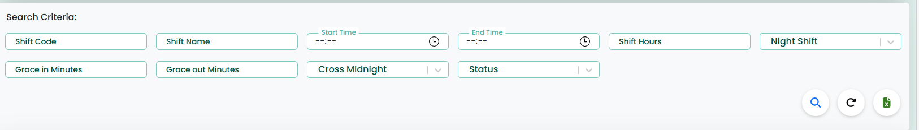
Search Actions
- Search
Retrieves project records based on selected criteria.
- Reload
Resets the search filters and reloads the data.
- Excel
The Excel button is used to export the displayed data into a downloadable Excel file.
GRID
The retrieved records will be displayed in a grid format, making it easier for users to view and manage the shift details. The grid also provides options to update or delete the existing records. Additionally, users 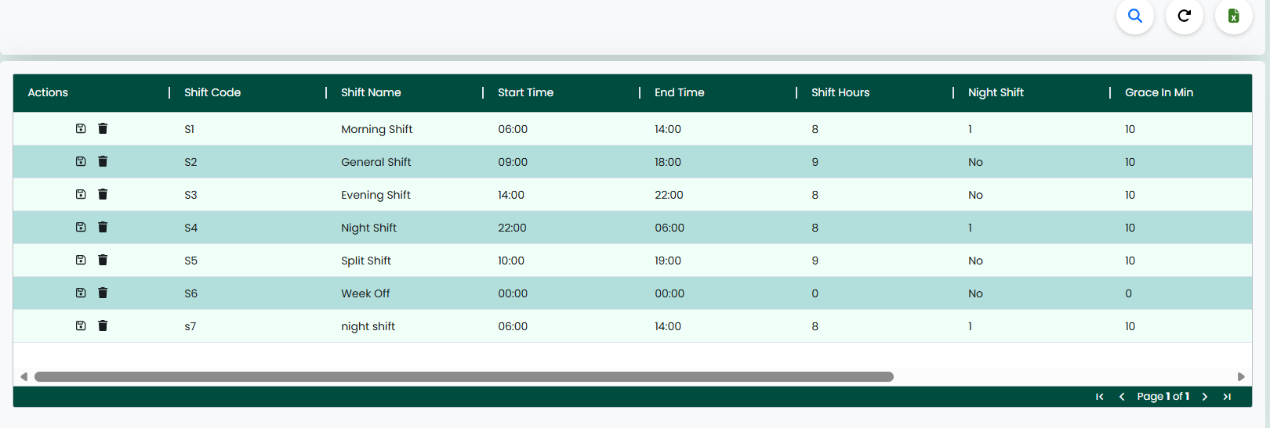can export the data using the Excel option.
Actions Buttons
- Update
Used to update the project details.
- Delete
Used to Delete the project details.

Shift Pattern Master
The Shift Pattern Master Screen allows users to create and manage shift patterns within the system. This screen is used to define rotation-based shift schedules for employees.
The screen includes input fields where users can enter shift pattern details such as shift pattern code, pattern name, rotation days, description, and status. After entering the details, the data can be saved and stored in the system.
The screen helps in organizing shifts in a structured pattern, making it easier to manage rotating shifts and assign them to employees efficiently.
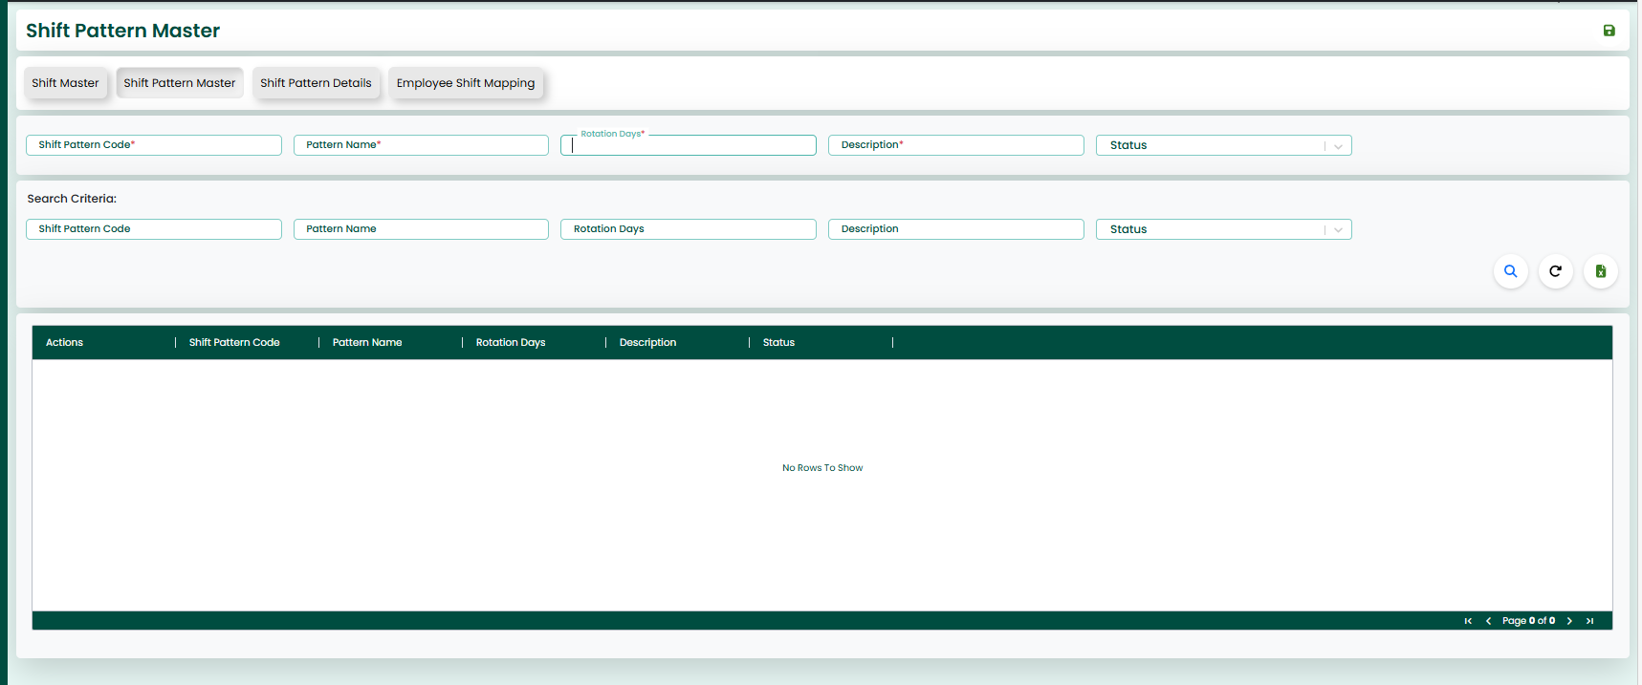
Action Buttons
- Save
Used to save the project details.
- Reload
Used to clear the entered data and refresh the screen.
Search Criteria :
The screen also provides search criteria fields, which allow users to filter and retrieve specific shift pattern records based on conditions such as shift pattern code, pattern name, rotation days, description, and status.
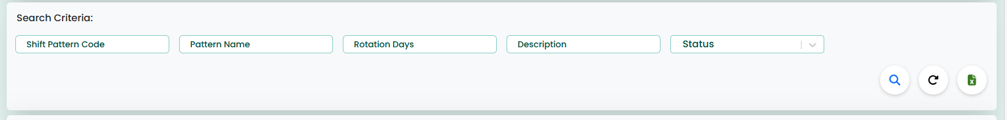
Search Actions
- Search
Retrieves project records based on selected criteria.
- Reload
Resets the search filters and reloads the data.
- Excel
The Excel button is used to export the displayed data into a downloadable Excel file.
GRID
The retrieved records will be displayed in a grid format, making it easier for users to view and manage the shift pattern details. The grid also provides options to update or delete the existing records. Additionally, users can export the data using the Excel option.
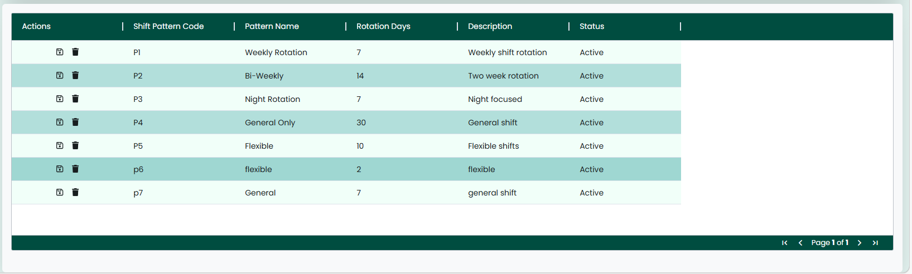
Actions Buttons
- Update
Used to update the project details.
- Delete
Used to Delete the project details.

Shift Pattern Details
The Shift Pattern Details Screen allows users to define and manage detailed shift pattern configurations within the system. This screen is used to assign specific shifts to each day in a rotation pattern.
The screen includes input fields where users can enter details such as shift pattern code, pattern detail code, day sequence, shift code, and whether it is an off day. These details help in defining how shifts are structured across multiple days. After entering the details, the data can be saved and stored in the system.
The screen plays an important role in setting up shift rotations by specifying which shift applies on each day and identifying off days within the pattern.

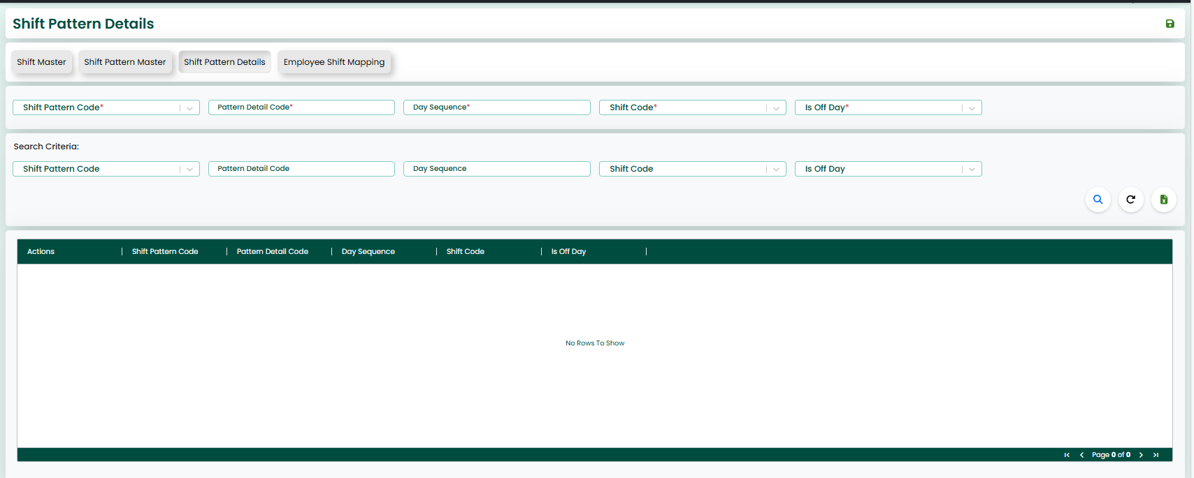
Action Buttons
- Save
Used to save the project details.
- Reload
Used to clear the entered data and refresh the screen.
Search Criteria :
The screen also provides search criteria fields, which allow users to filter and retrieve specific shift pattern detail records based on conditions such as shift pattern code, pattern detail code, day sequence, shift code, and off day status.
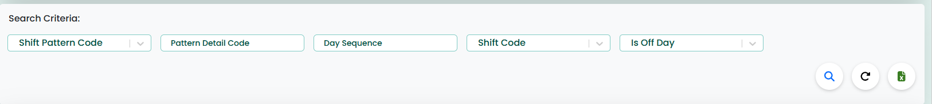
Search Actions
- Search
Retrieves project records based on selected criteria.
- Reload
Resets the search filters and reloads the data.
- Excel
The Excel button is used to export the displayed data into a downloadable Excel file.

GRID
The retrieved records will be displayed in a grid format, making it easier for users to view and manage the shift pattern details. The grid also provides options to update or delete the existing records. Additionally, users can use search and reload options to manage the data efficiently.
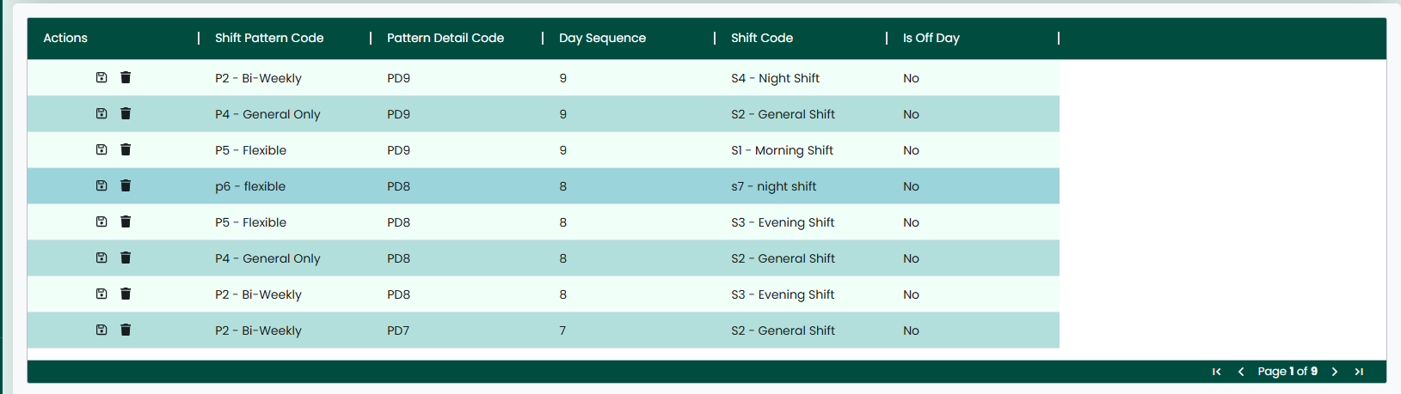
Actions Buttons
- Update
Used to update the project details.
- Delete
Used to Delete the project details.

Employee Shift Mapping
The Employee Shift Mapping Screen allows users to assign and manage shift patterns for employees within the system. This screen is used to map employees to specific shift patterns for a defined period.
The screen includes input fields where users can enter details such as employee ID, shift pattern ID, effective from date, effective to date, and status. These details help in assigning the correct shift pattern to employees for a specific duration. After entering the details, the data can be saved and stored in the system.
The screen ensures proper scheduling by linking employees with predefined shift patterns, helping in accurate attendance tracking and shift management.
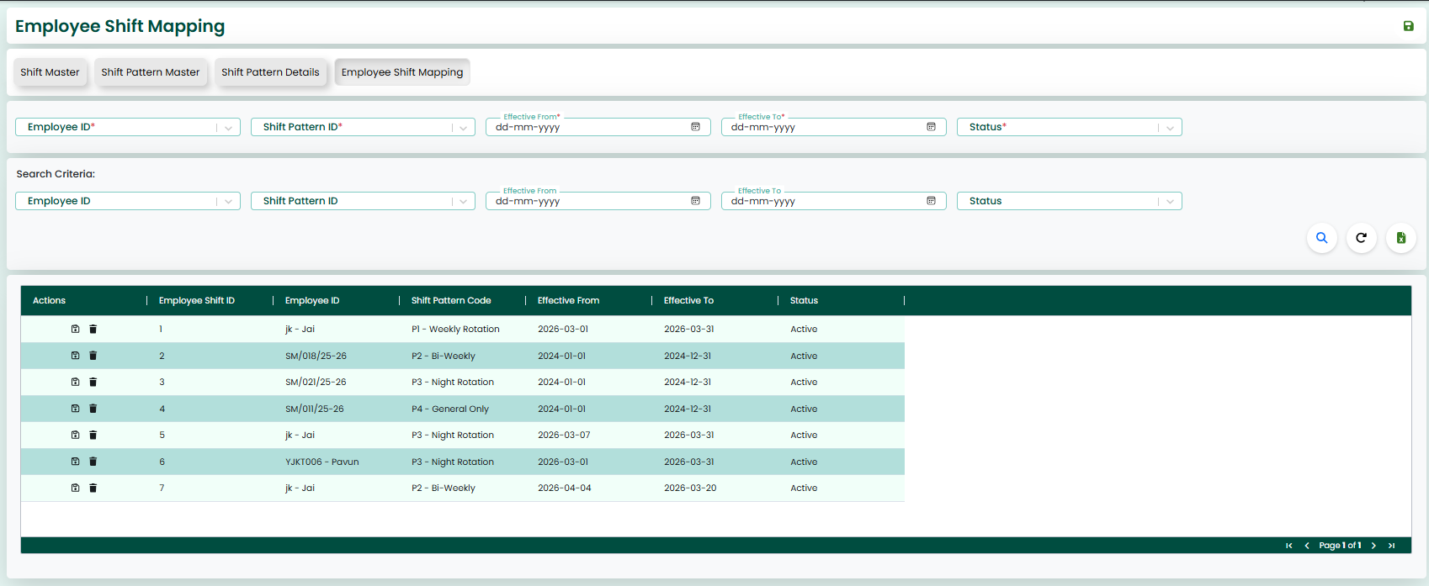
Action Buttons
- Save
Used to save the project details.
- Reload
Used to clear the entered data and refresh the screen.
Search Criteria :
The screen also provides search criteria fields, which allow users to filter and retrieve specific employee shift mapping records based on conditions such as employee ID, shift pattern ID, effective date range, and status.
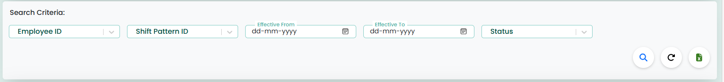

Search Actions
- Search
Retrieves project records based on selected criteria.
- Reload
Resets the search filters and reloads the data.
- Excel
The Excel button is used to export the displayed data into a downloadable Excel file.
GRID
The retrieved records will be displayed in a grid format, making it easier for users to view and manage the mapping details. The grid also provides options to update or delete the existing records. Additionally, users can export the data using the Excel option.
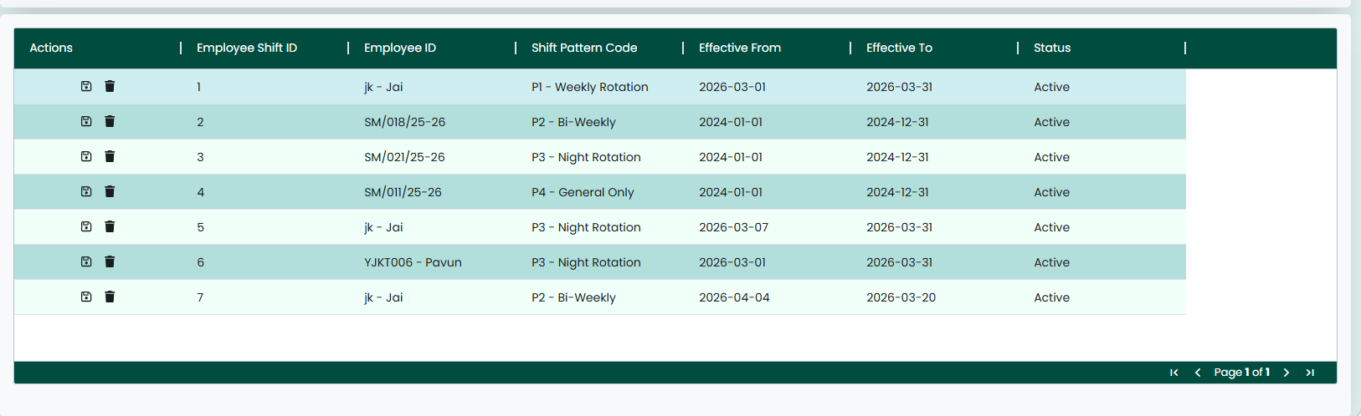
Actions Buttons
- Update
Used to update the project details.
- Delete
Used to Delete the project details.

C H A P T E R

Transaction

The Transactions Section is used to perform daily operational activities in the system. It helps users manage tasks, update work progress, and generate employee shifts based on predefined configurations.
It includes features such as Open Tickets, Task Update, and Generate Shift, which support smooth workflow management and efficient task handling.
Additional Points
- Helps in real-time task tracking and updates
- Enables users to manage and monitor pending work (tickets)
- Supports updating task progress and work details
- Allows automatic shift generation based on shift patterns
- Improves workflow efficiency and productivity
- Reduces manual errors in task and shift management
- Provides better visibility of ongoing activities
- Ensures proper coordination between users and management

Open Ticket

The Open Tickets Screen allows users to view and manage all active and pending tasks within the system. This screen is used to track ongoing work and monitor task status effectively.
The screen displays ticket details in a grid format, including information such as project ID, project name, task master ID, task title, start date, end date, user ID, user name, task status, priority level and description. This helps user s get a clear view of all assigned and pending tasks.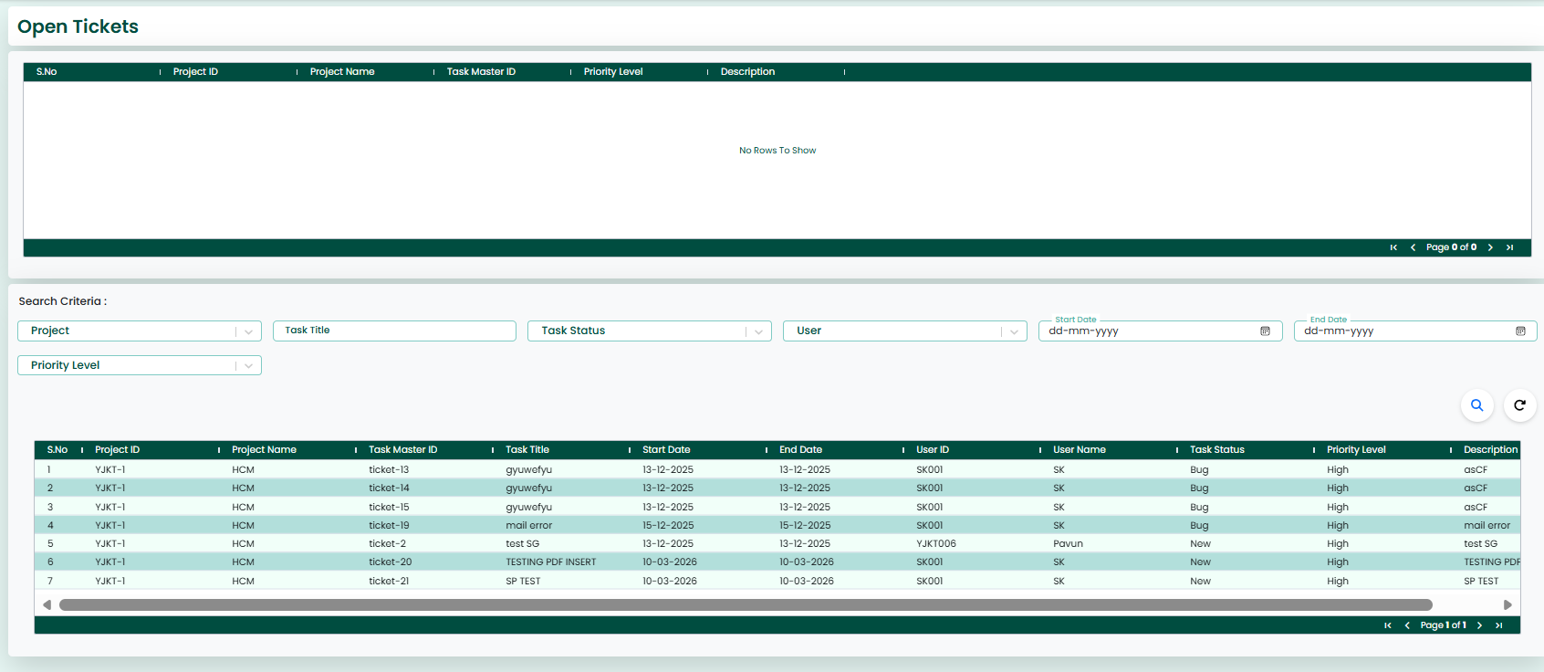

Search Criteria :
The screen also provides search criteria fields, which allow users to filter and retrieve specific ticket records based on conditions such as project, task title, task status, user, priority level, and date range. 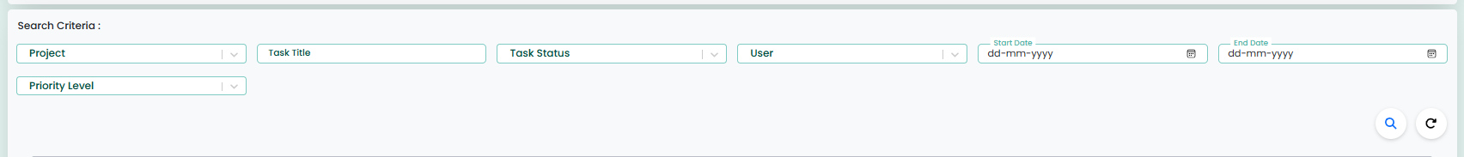
Search Actions
- Search
Retrieves project records based on selected criteria.
- Reload
Resets the search filters and reloads the data.
- Excel
The Excel button is used to export the displayed data into a downloadable Excel file.
GRID
The retrieved records are displayed in a structured grid format, making it easier for users to view and manage the tickets. Users can track task progress, identify pending work, and take necessary actions accordingly.
This screen helps in improving task tracking, workload management, and overall workflow efficiency within the organization.
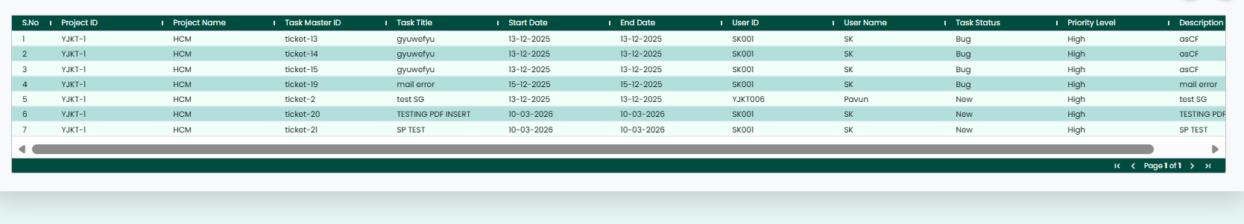

Task Update
The Task Update Screen allows users to update and manage task progress within a selected project. This screen is used to record daily work updates, track task completion, and maintain task-related information.
The screen displays project details such as project name, project description, project manager, start date, and end date. It also provides a task list grid where users can view existing tasks based on search criteria.
The screen includes input fields where users can enter or update task details such as task title, user, estimated hours, buffer hours, task status, priority level, start date, end date, and task description. Users can also upload files related to the task and record total hours spent on the task.
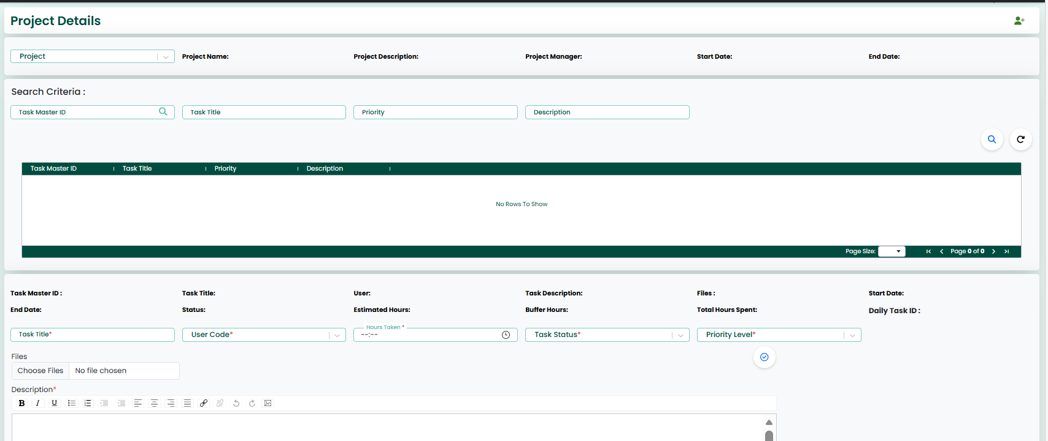
Search Criteria :
The screen also provides search criteria fields, which allow users to filter and retrieve specific task records based on task master ID, task title, priority, and description.The Task History section displays previously recorded task updates, including task date, user details, hours taken, task status, and description. This helps in tracking the progress and history of each task.
The data entered can be saved and stored in the system, and users can continuously update task progress as work is completed.
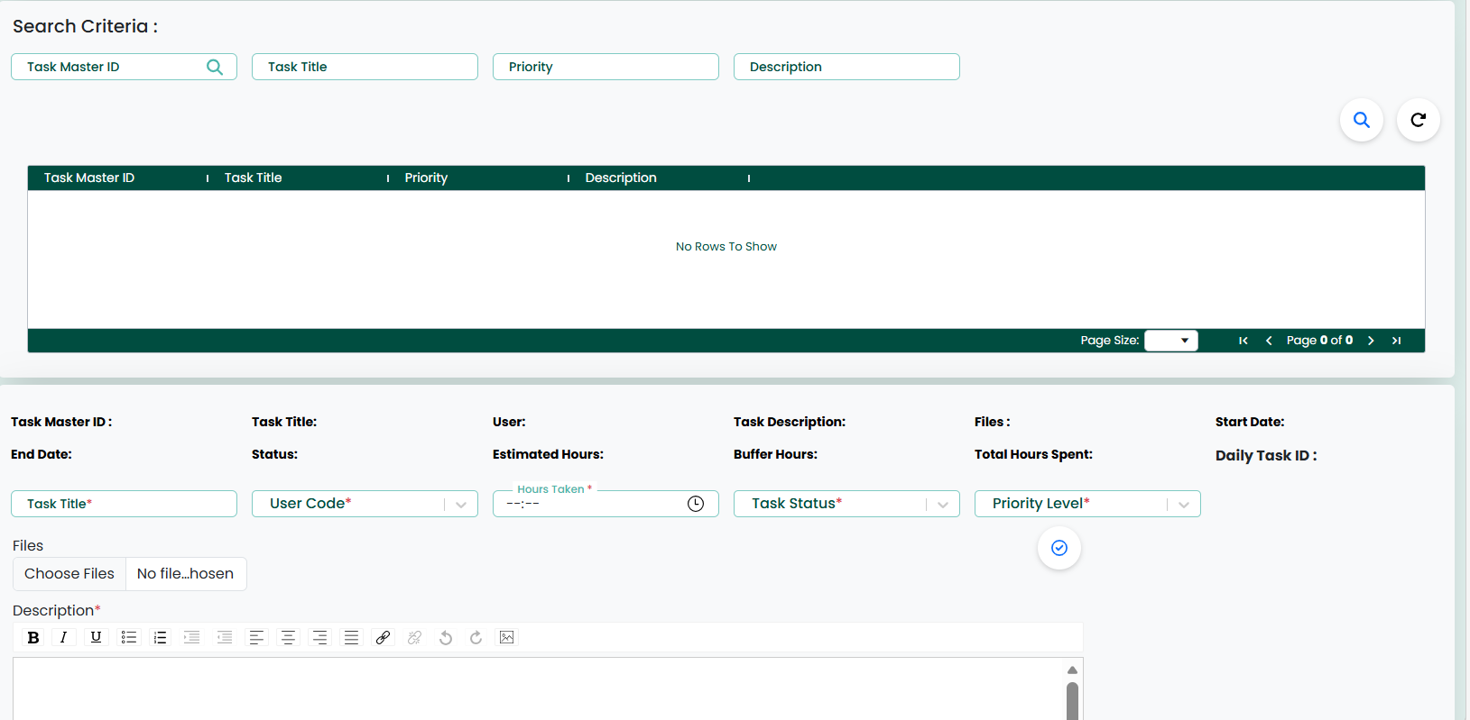

Add Task Master Screen
The Add Task Master Screen allows users to create and define new tasks within a project. This screen is used to assign tasks to users and set up task-related details for proper tracking and execution.
The screen includes input fields where users can enter task information such as project ID, task master ID, task title, user ID, start date, end date, estimated hours, buffer hours, task description, task status, and priority level. These details help in clearly defining the task and assigning responsibility.
After entering the required details, users can click on the Submit button to save the task information in the system. The created task will then be available for tracking and updates in the task management process.
This screen helps in organizing tasks efficiently, ensuring proper assignment, and improving overall project management and workflow.
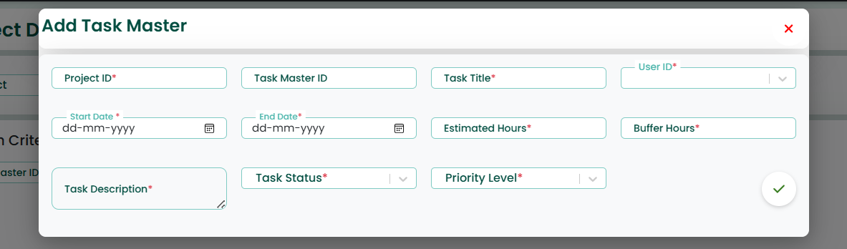

Generate Shift Screen
The Generate Shift Screen allows users to generate and assign shifts to employees based on selected criteria. This screen is used to automate shift allocation for employees within a specific date range.
The screen includes input fields where users can select details such as department, designation, employee ID, from date, and to date. These inputs help in defining which employees should receive shift assignments and for what period.
After entering the required details, the system generates shifts based on predefined shift patterns and assigns them to the selected employees.
This screen helps in reducing manual effort in shift assignment, ensuring accurate scheduling, and maintaining consistency in employee shift allocation.

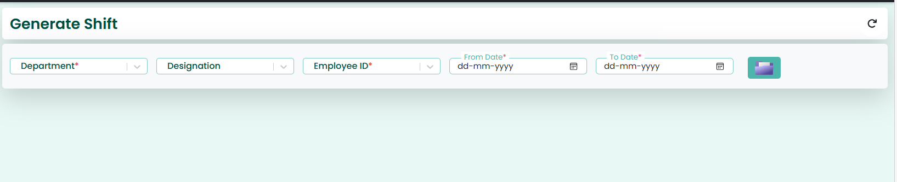

4. Report
A Report is a feature that displays system data in a structured and meaningful format. It helps users analyze, monitor, and understand information related to tasks, projects, and employee activities.
In this system, reports such as Task Hours & Time Tracking, Project Progress, Project Chart Report, and Shift Summary Report provide insights into work performance, time utilization, project status, and shift details.
Reports – Additional Points
- Provides real-time data insights for better decision-making
- Helps in monitoring employee performance and productivity
- Enables tracking of task completion and time utilization
- Gives clear visibility of project progress and status
- Supports shift and attendance analysis
- Reduces manual effort in data collection and reporting
- Allows users to filter and customize reports based on requirements
- Improves accuracy and transparency of data
- Helps management in planning and resource allocation
- Data can be exported (Excel/PDF) for sharing and documentation

Task Hours and Time Tracking
This screen is used to monitor and analyze employee working hours, shift timings, and task time tracking in a centralized view.
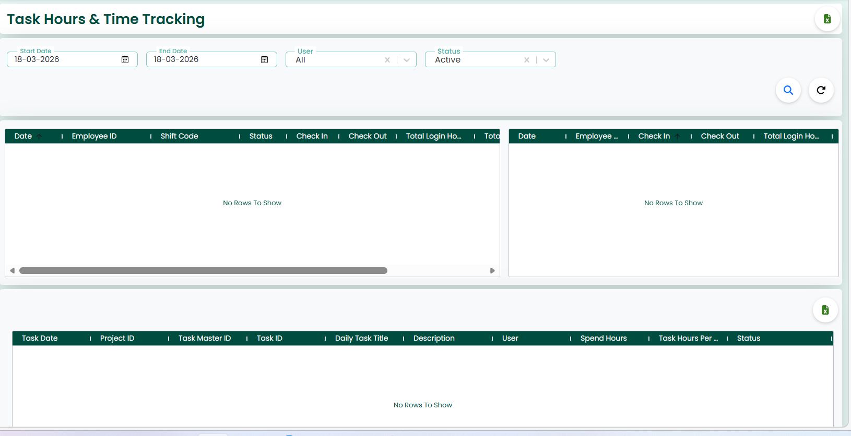
Top Filters Section
- Start Date / End Date – Select the date range to view records
- User – Filter data by specific employee or view all
- Status – Filter by task/shift status (e.g., Active, Inactive)
- Search Icon – Fetch data based on selected filters
- Reload Icon – Reset filters and refresh data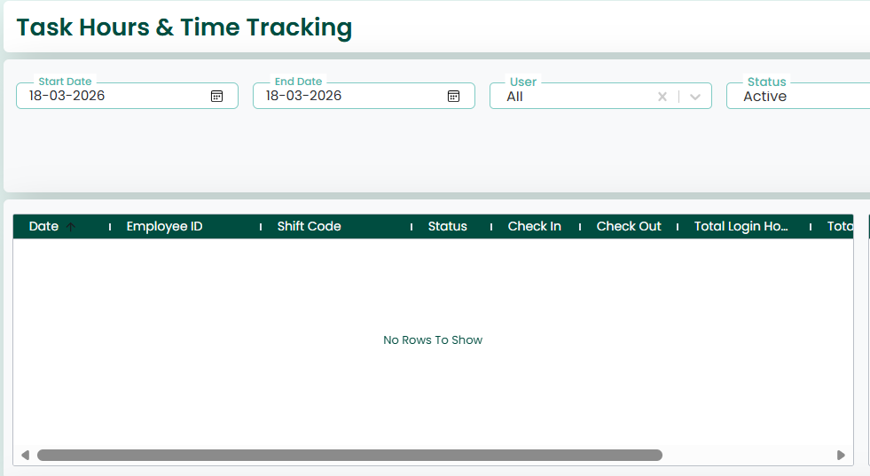
Section 1: Shift & Login Details (Left Grid)
Displays:
- Date
- Employee ID
- Shift Code
- Status
- Check-In Time
- Check-Out Time
- Total Login Hours
Helps track attendance and shift timing details
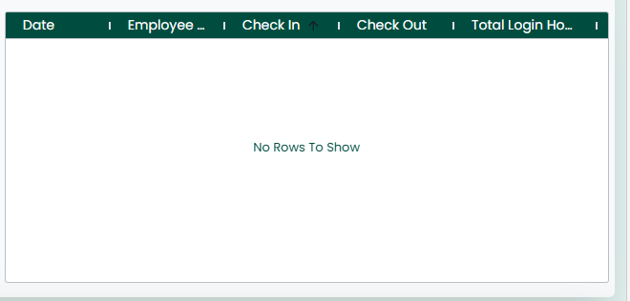
Section 2: Login Summary (Right Grid)
Displays:
- Date
- Employee ID
- Check-In / Check-Out
- Total Login Hours
Provides a quick summary of login activity


Section 3: Task Time Tracking (Bottom Grid)
Displays:
- Task Date
- Project ID
- Task Master ID
- Task ID
- Daily Task Title
- Description
- User
- Spent Hours
- Task Hours
- Status
Helps track time spent on each task and work progress
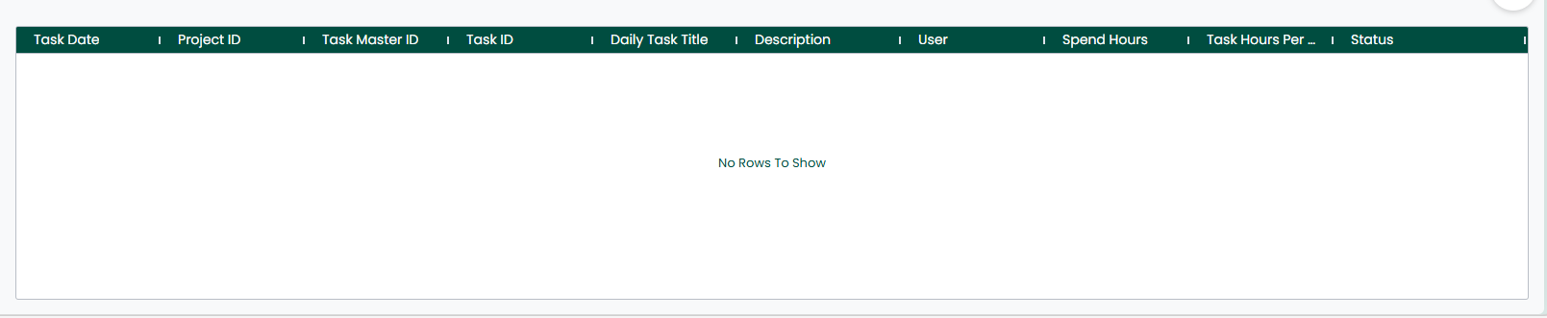
- Excel Export Icon – Download report data in Excel format
- Scrollable Grids – View large datasets easily
- Multiple Data Views – Combines shift, login, and task tracking in one screen

Project Progress
The Project Progress Screen allows users to track and monitor the progress of projects and their associated tasks within the system. This screen is used to analyze project performance by comparing planned and actual work.
The screen includes input fields where users can enter details such as project ID, project name, project manager, start date, end date, and priority level. These details help in filtering and viewing specific project records based on requirements. After applying the filters, the relevant project data is displayed on the screen.
The screen displays project-level information such as project name, priority, timeline, manager, estimated hours, and actual hours, which helps in understanding the overall project status. It also provides task-level details including task ID, task title, assigned user, estimated hours, actual hours, and description, enabling detailed analysis of individual task performance.
The screen ensures effective project monitoring by providing a clear comparison between estimated and actual efforts, helping in identifying delays, improving resource utilization, and supporting better decision-making.
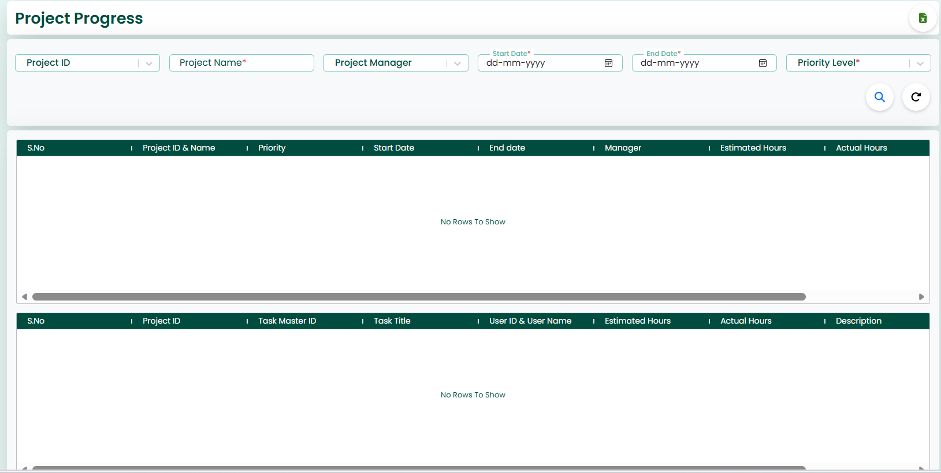
Action Buttons
- Excel
The Excel button is used to export the displayed data into a downloadable Excel file.

Search Actions
- Search
Retrieves project records based on selected criteria.
- Reload
Resets the search filters and reloads the data.
GRID
The screen provides search and filter options that allow users to retrieve specific project data based on selected criteria. Users can filter records using fields such as project ID, project name, project manager, start date, end date, and priority level.
After entering the required search criteria, users can click on the Search option to view the filtered results. The system will display only the relevant project and task details based on the selected conditions.
The Reload option is used to clear all selected filters and refresh the screen to display default data.
These search and filter features help users to quickly find required information, improve data visibility, and make efficient decisions.
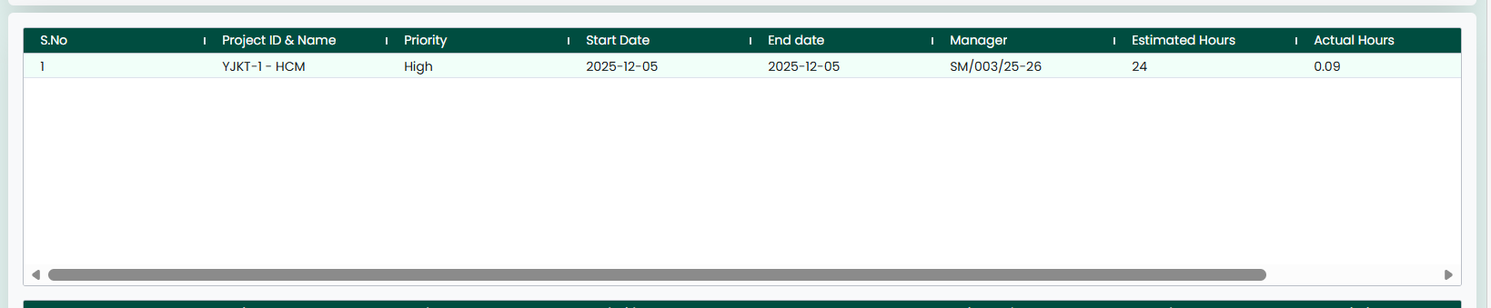

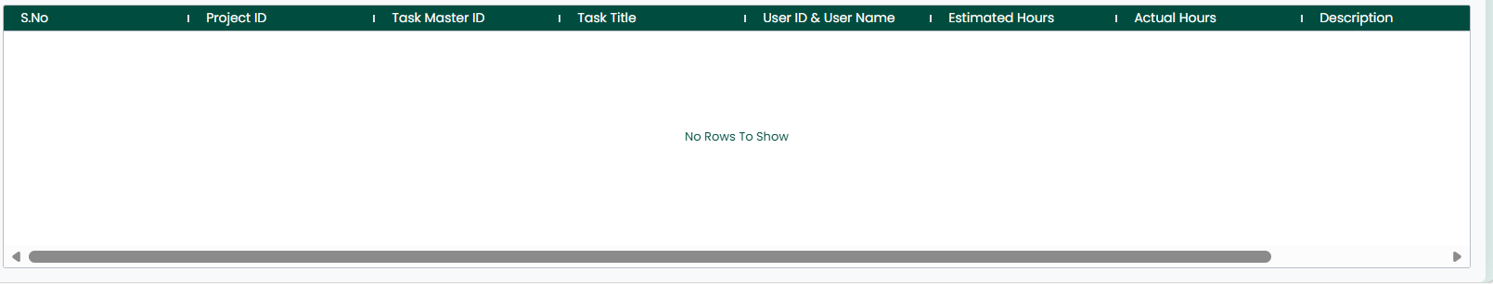

Project chart Report
The Project Chart Report Screen allows users to visualize and analyze project performance using graphical charts. This screen is used to compare planned and actual work and to understand project progress in an easy and visual format.
The screen includes filter options where users can select details such as project, employee, and other criteria to view specific data. Based on the selected filters, the system displays chart-based reports.
The Project Analysis section shows a comparison between planned and actual values for a selected project. This helps users understand how much work was planned versus how much has been completed.
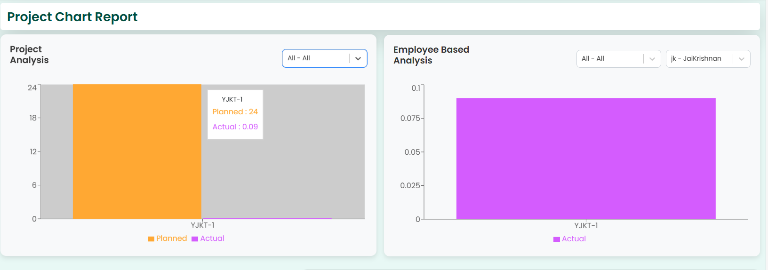

The Employee Based Analysis section provides insights into employee-wise performance, showing how each employee has contributed to the project.
The charts make it easier to analyse data visually, identify trends, and understand performance differences quickly.

Shift Summery Report
The Shift Summary Report Screen allows users to view and analyze employee shift details within a selected date range. This screen is used to track shift allocation and attendance summary for employees.
The screen includes input fields where users can enter details such as employee ID, shift name, from date, and to date. These fields help in filtering and retrieving specific shift records based on user requirements.

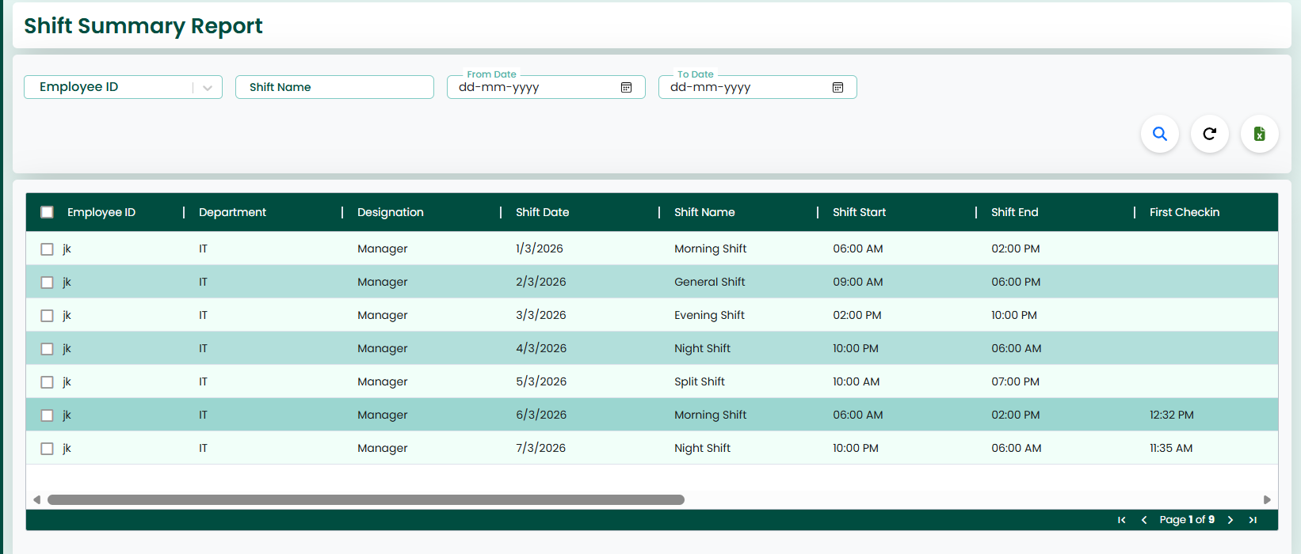
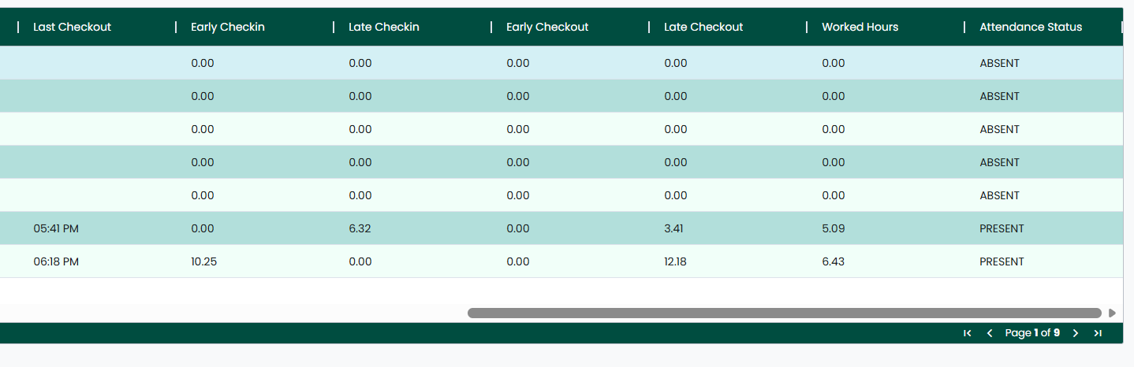
After entering the required details, users can click on the Search option to view the filtered results. The system will display the shift summary data based on the selected criteria.
The Reload option is used to clear all filters and refresh the screen to display default data.
The retrieved records are displayed in a structured format, making it easier for users to view employee shift details such as assigned shifts and working days.
Additionally, the Excel option allows users to export the shift summary data into an Excel file for further analysis, sharing, and record-keeping.

